CDOT Summary of Findings for I-25 and 470 Centerlines

1. Bing VirtualEarth satellite was used for this map. It appeared to have more updated road construction. When Bing VirtualEarth was too blurry to see lane lines, Mapbox Satellite Streets was used. These maps lined up very closely in most areas, except where there was new construction and a new lane was added.
2. Below are screenshots where the road is larger than the 11 meter buffer minus the 2 meter reference data accuracy.
   1. 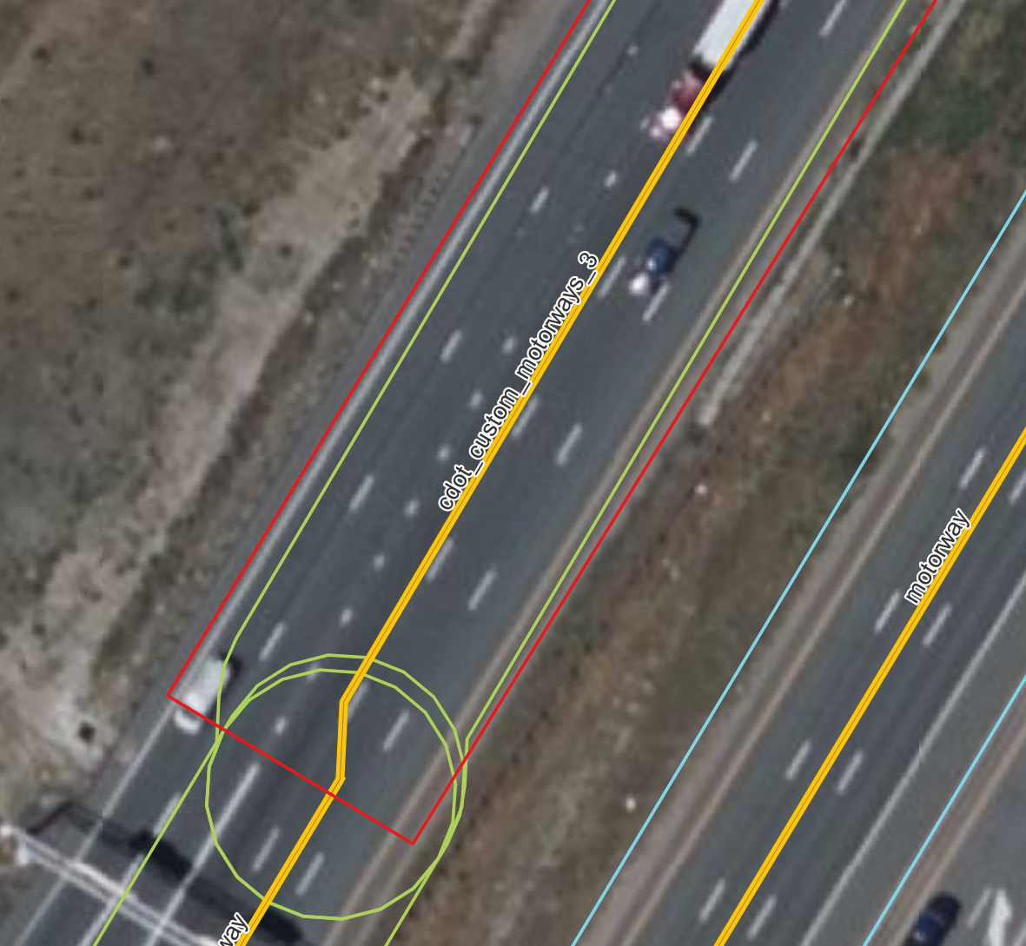cdot_custom_motorways_3 – the light green buffer does not reach the outside of the right most lane in both of these pictures
   2. 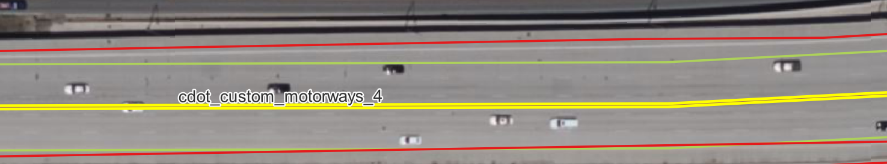cdot_customer_motorways_4 – the light green buffer does not reach the right most lane line
   3. 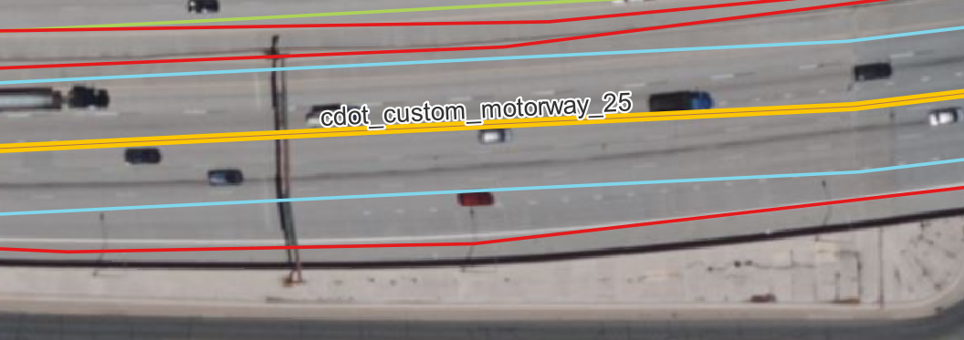Cdot_custom_motorway_25 – The blue buffer is very far away from the left most lane line (merge lane)
   4. 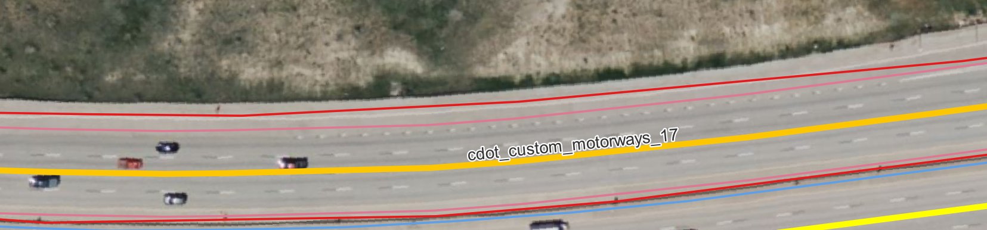Cdot_custom_motorway_17 – The pink buffer line doesn’t reach the left most side of the rode near the merge lane
   5. 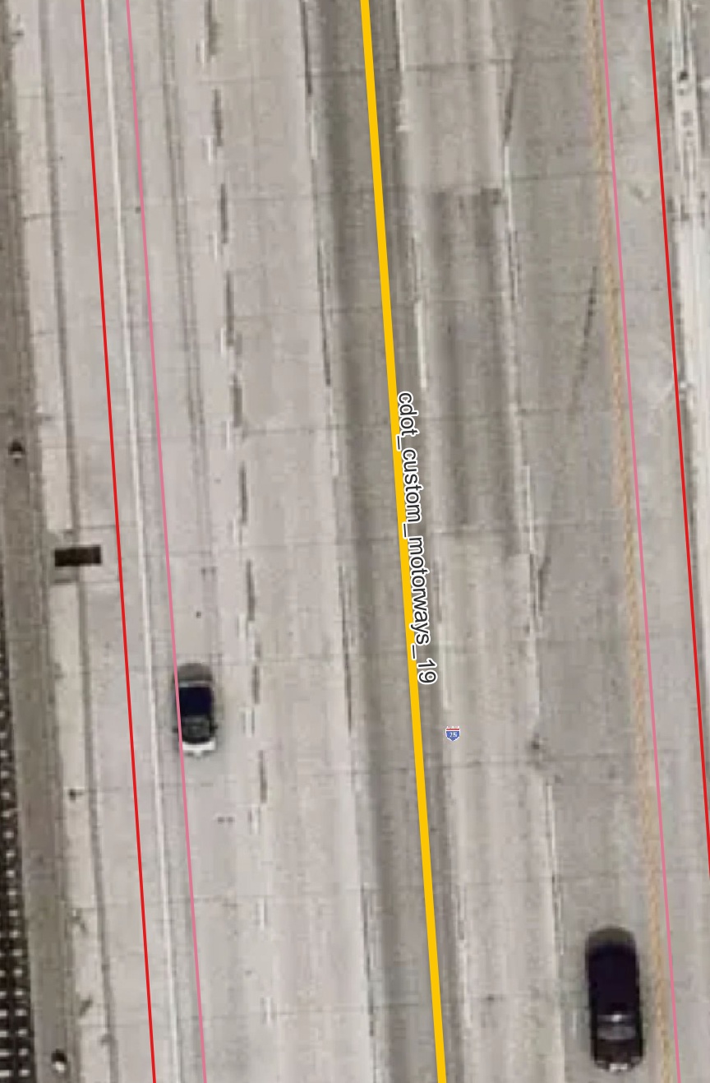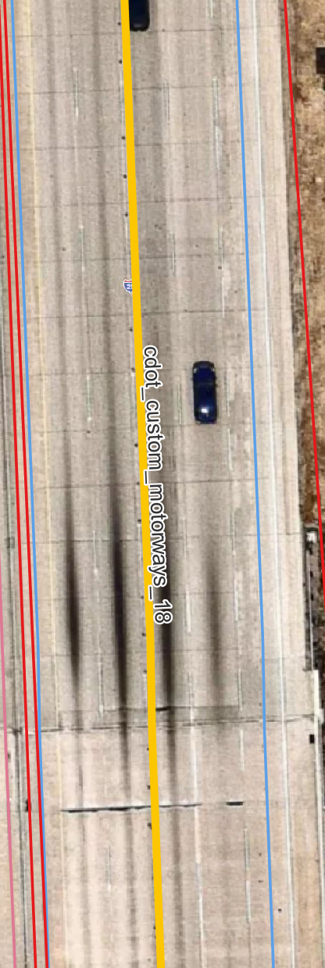Cdot_custom_motorway_18 – the blue buffer line is not outside the lane line
   6. Cdot_custom_motorways_19 – Right most lane line is outside the pink buffer

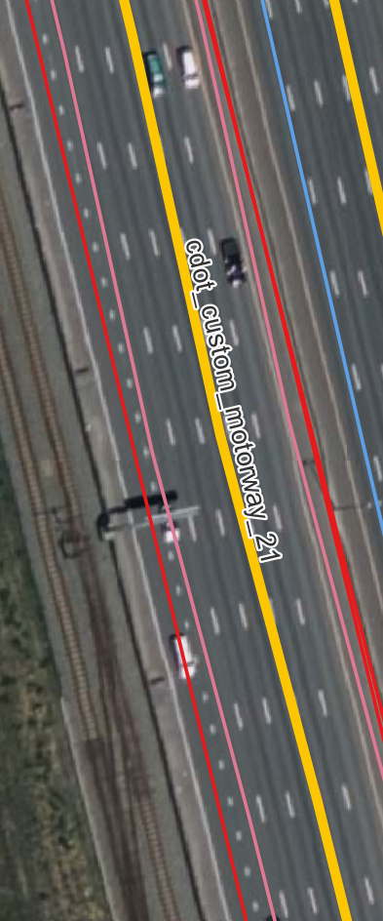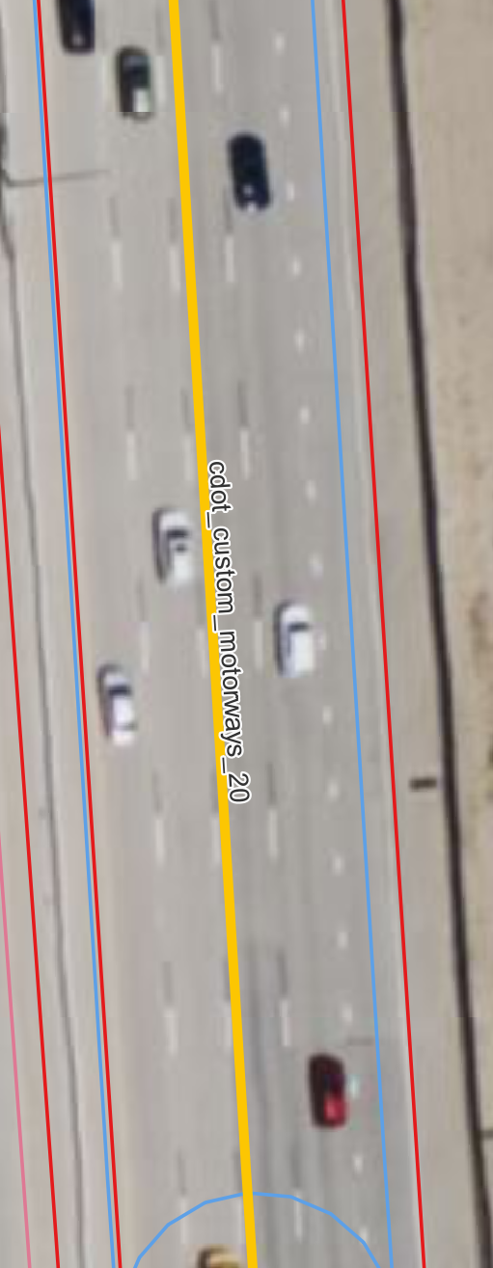H. cdot_custom_motorways_20 – The right most lane line is outside the blue buffer

I. cdot_custom_motorways_21 – The right most lane (merge lane) is outside the pink buffer

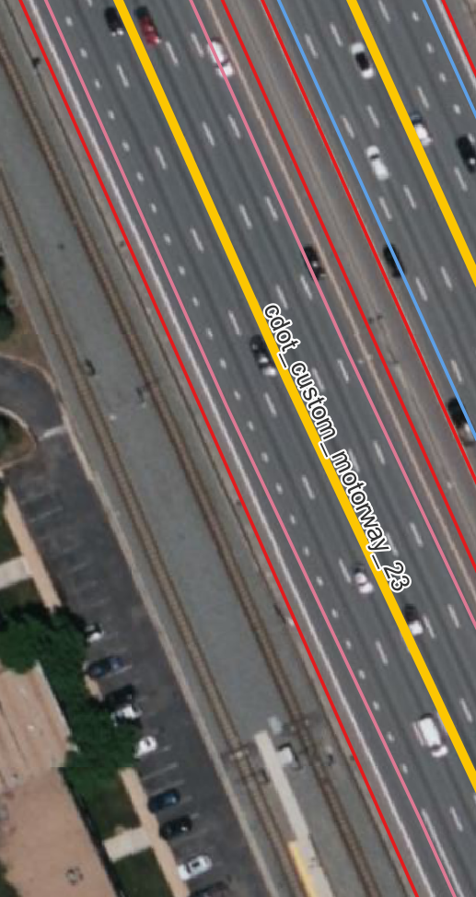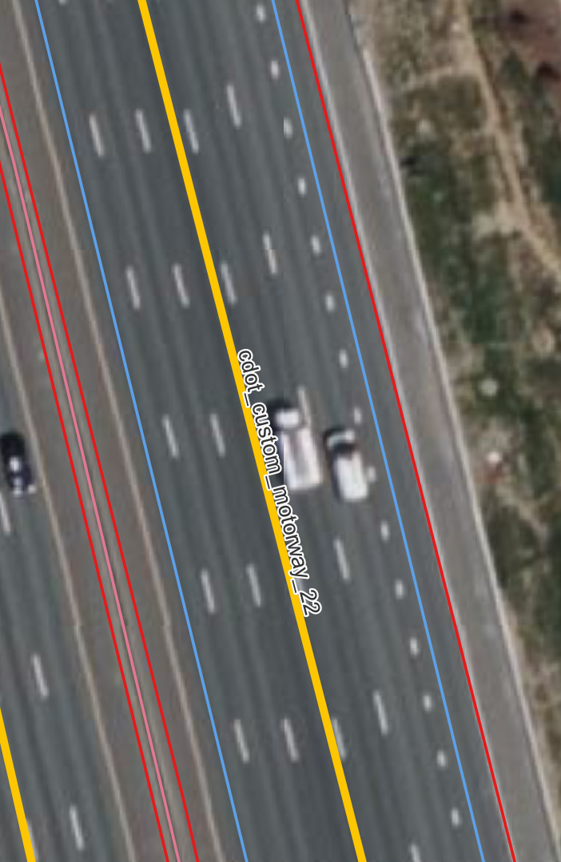J. cdot_custom_motorways_22 – The right and left most lanes are not within the blue buffer

K. cdot_custom_motorways_23 – The outside lane lines on both side are not within the pink buffers

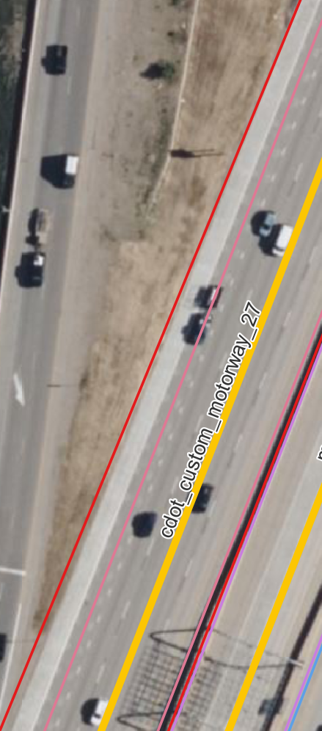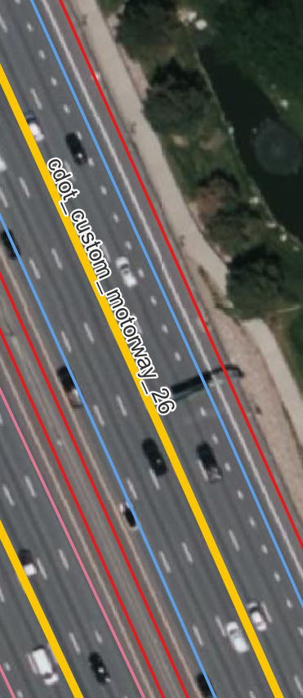L. cdot_custom_motorways_26 - The outside lane lines on both side are not within the pink buffers

M. cdot_custom_motorways_27 – The right most lane (merge lane) is not within the pink buffer

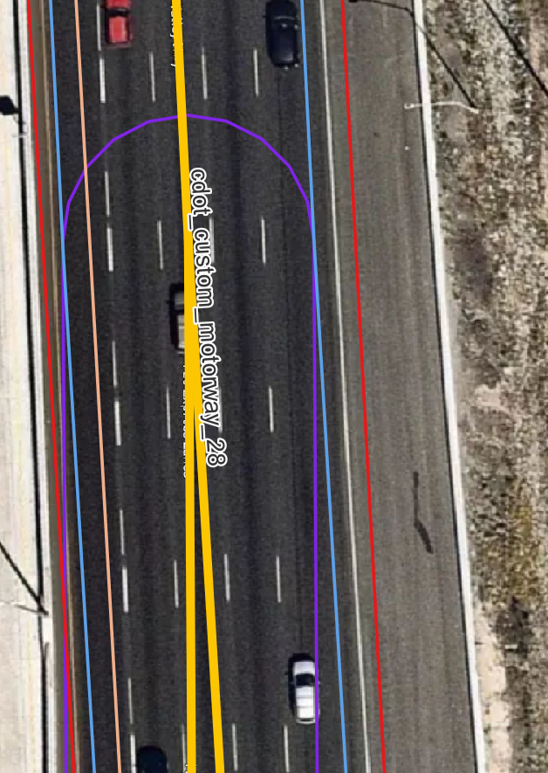N. cdot_custom_motorways_28 – The right most lane is not within the blue buffer

O. cdot_custom_motorway_29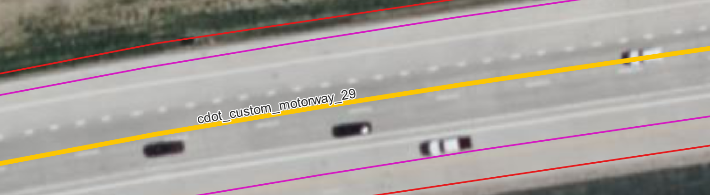 – The lane in the right most part of the highway is not fully in the purple buffer

Q. Cdot_custom_motorway_31 – The right most lane is not fully within the purple buffer

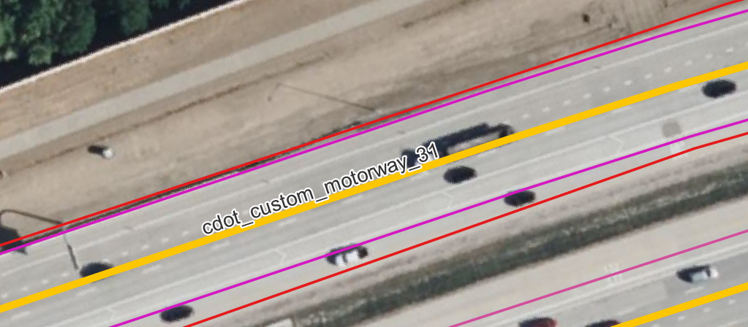

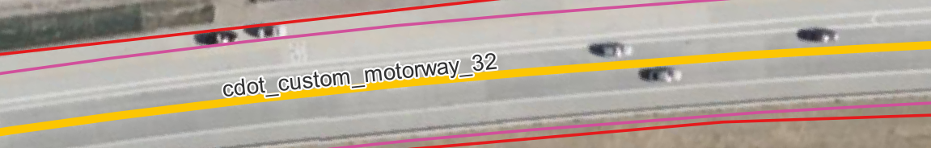 R. Cdot_custom_motorway_32 – The left most lane is not fully within the pink buffer

S. Cdot_custom_motorway_33 – The left most lane is not fully within in the purple buffer

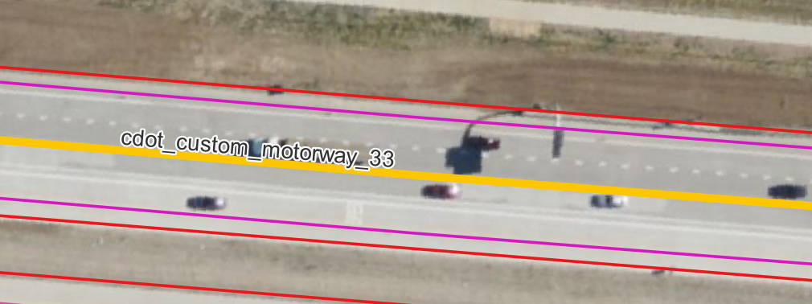

T. Cdot_custom_motorway_34 – The left most lane is not fully within the purple buffer

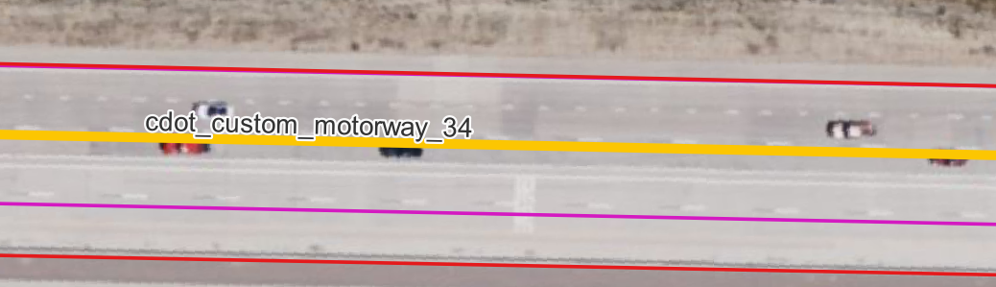

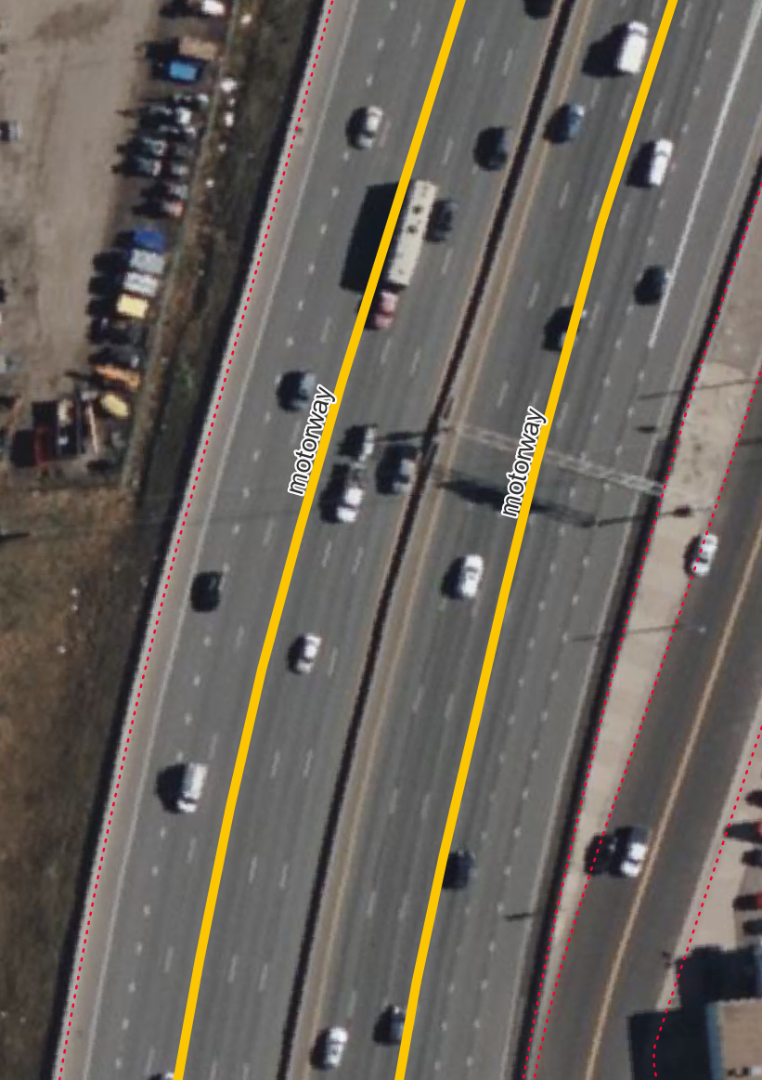Below are pictures of the City of Denver. The Edge of Pavement layer was used for reference here. This layer is extremely accurate at defining the lanes.

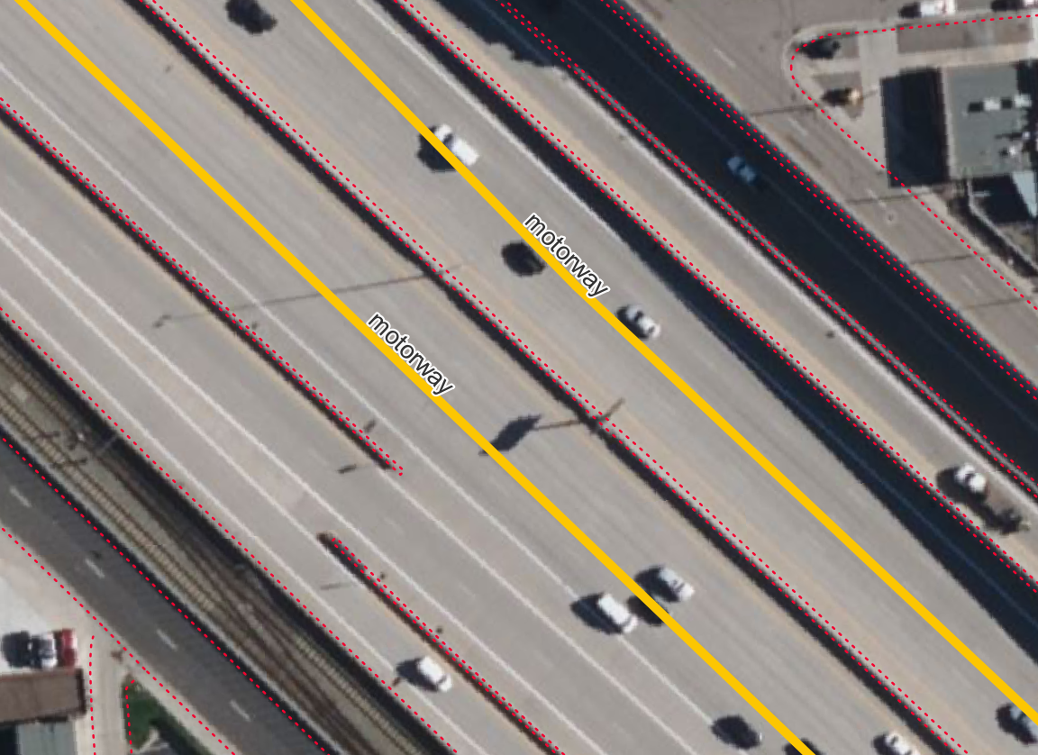

Original map vs edited map

1. Original – The centerlines are not even on the road here (west E-470)

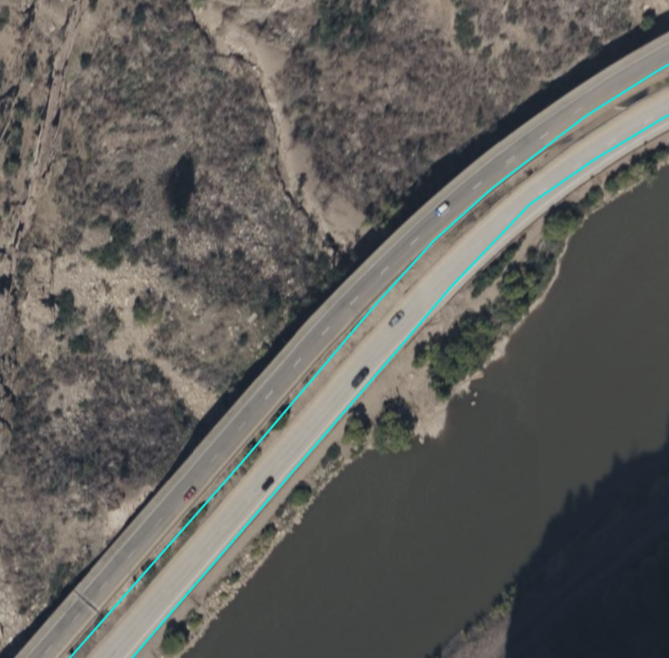

1. Edited map – Here the centerlines are placed in the middle of the road (west E-470)

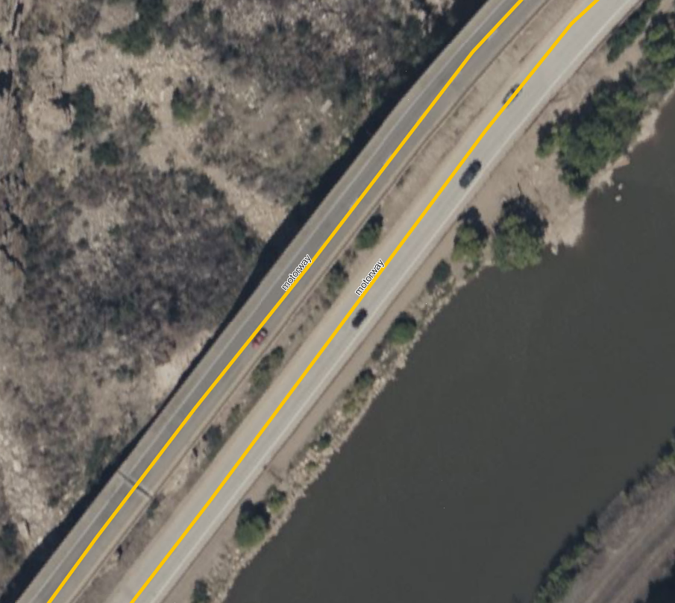

1. Original map – Centerlines are not located on the road (west E-470)

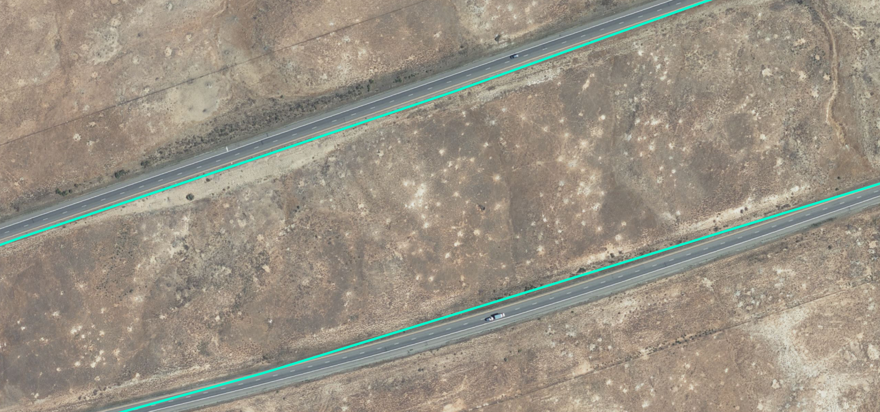

1. Edited map = Centerlines are now properly placed in the middle of the road (west E-470)

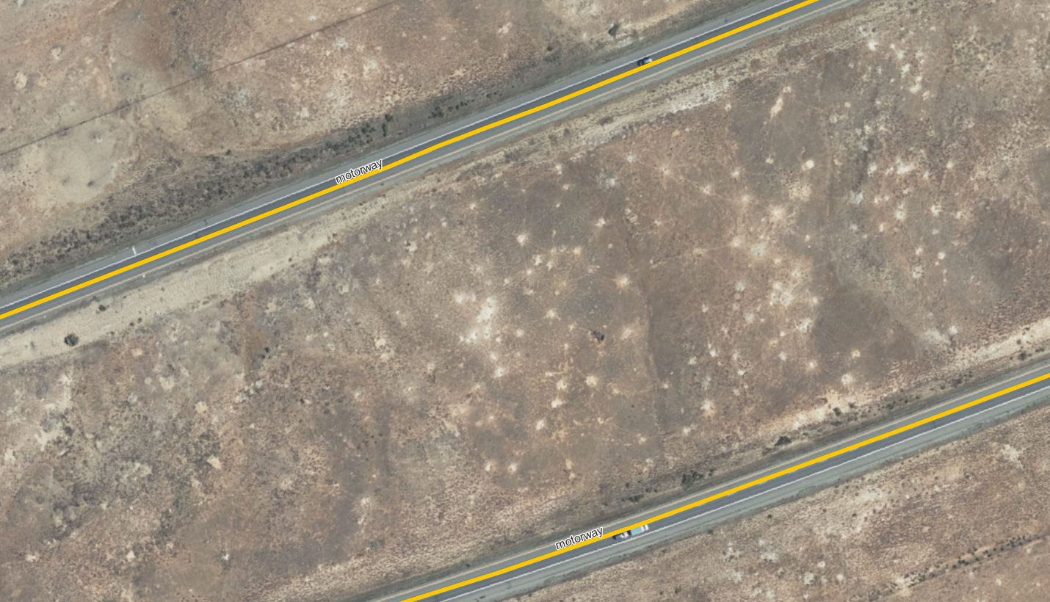

1. 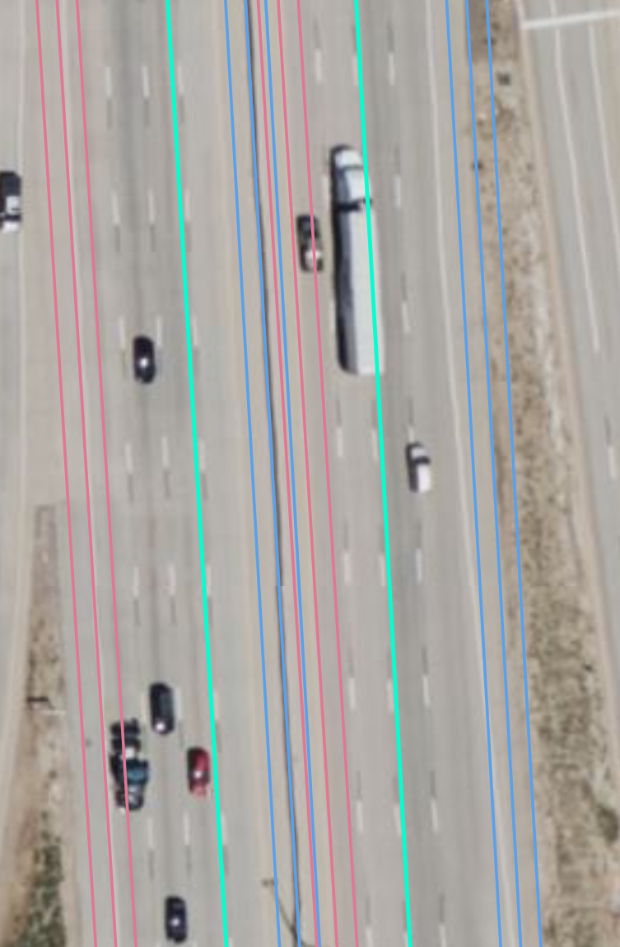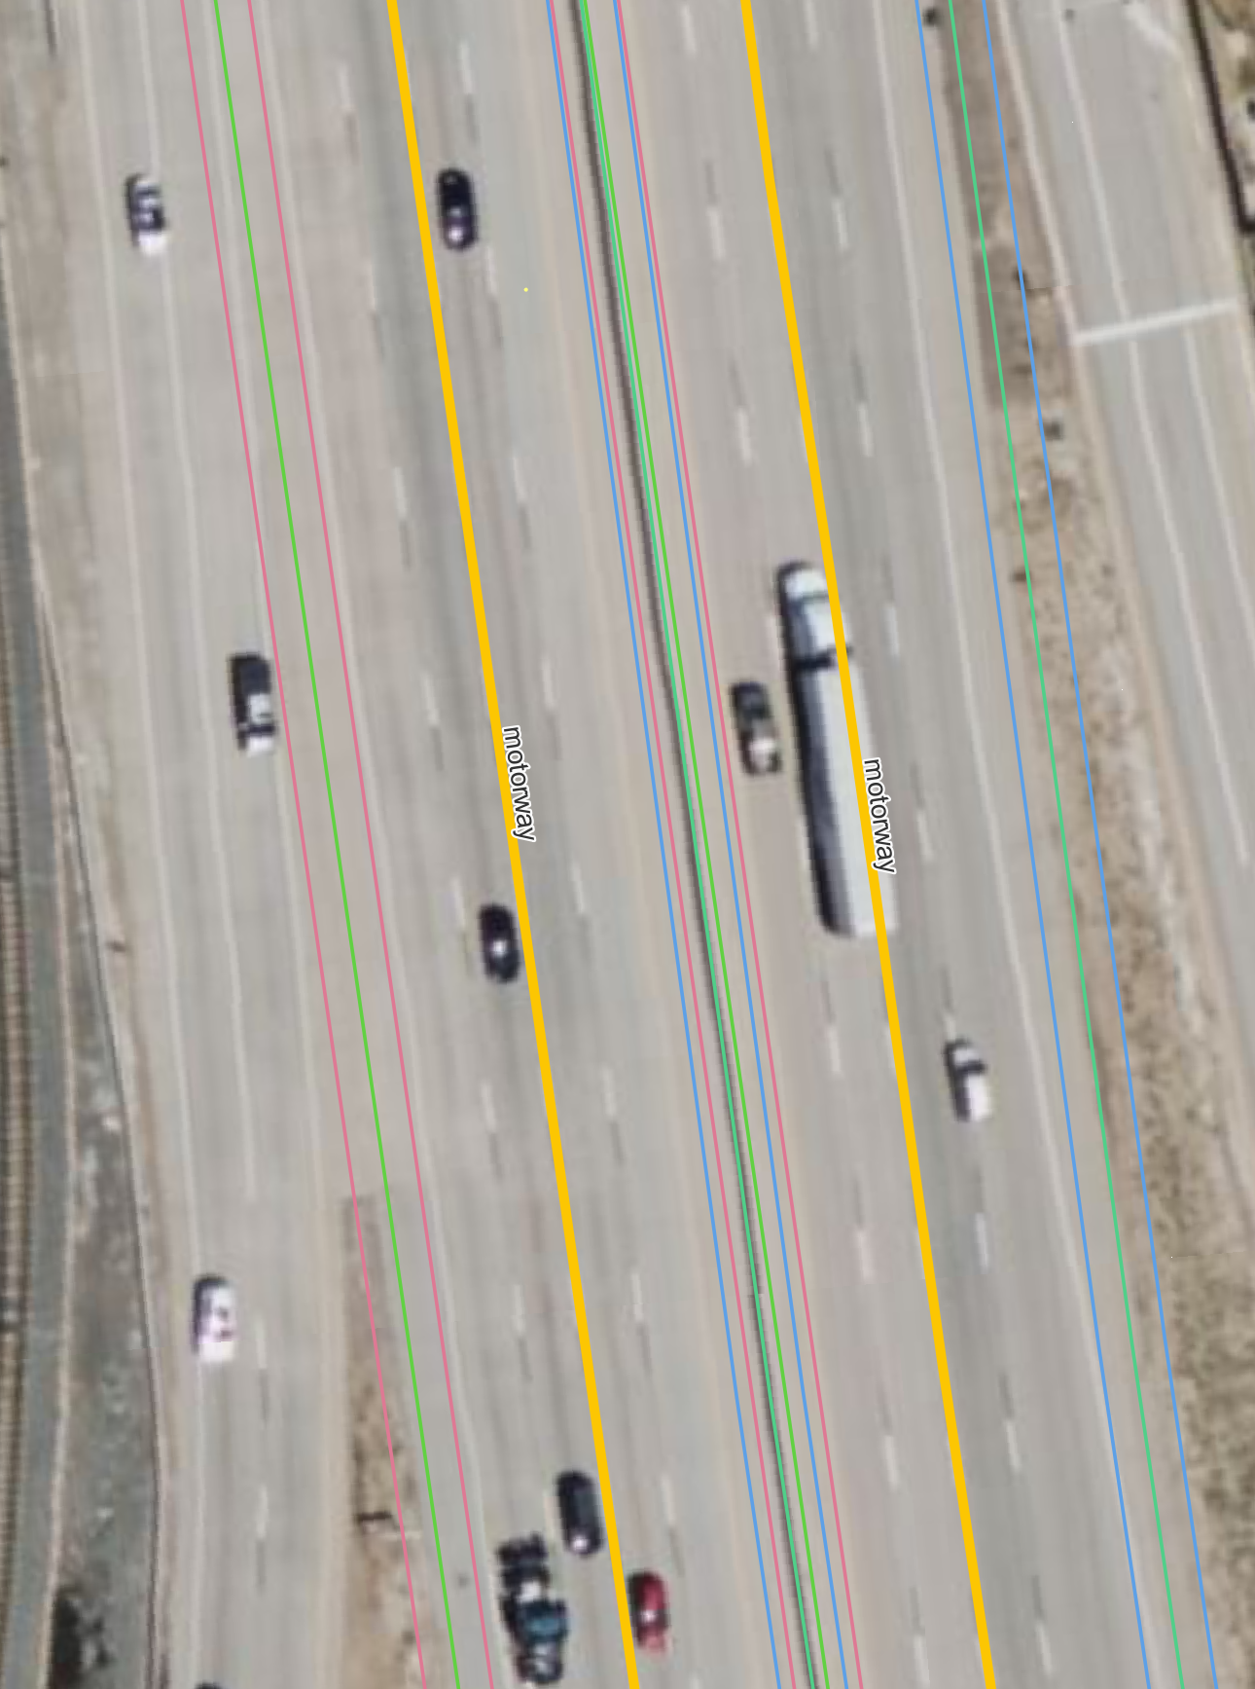Original map – Here you can see the south lanes on I-25 do not fit inside the pink buffers because the centerline was not located in the center of the road (I-25 south of E-470 intersec)
2. Edited map – The centerline was edited to be in the center and now the lanes fit in all three buffers (I-25 south of E-470 intersec)
3. 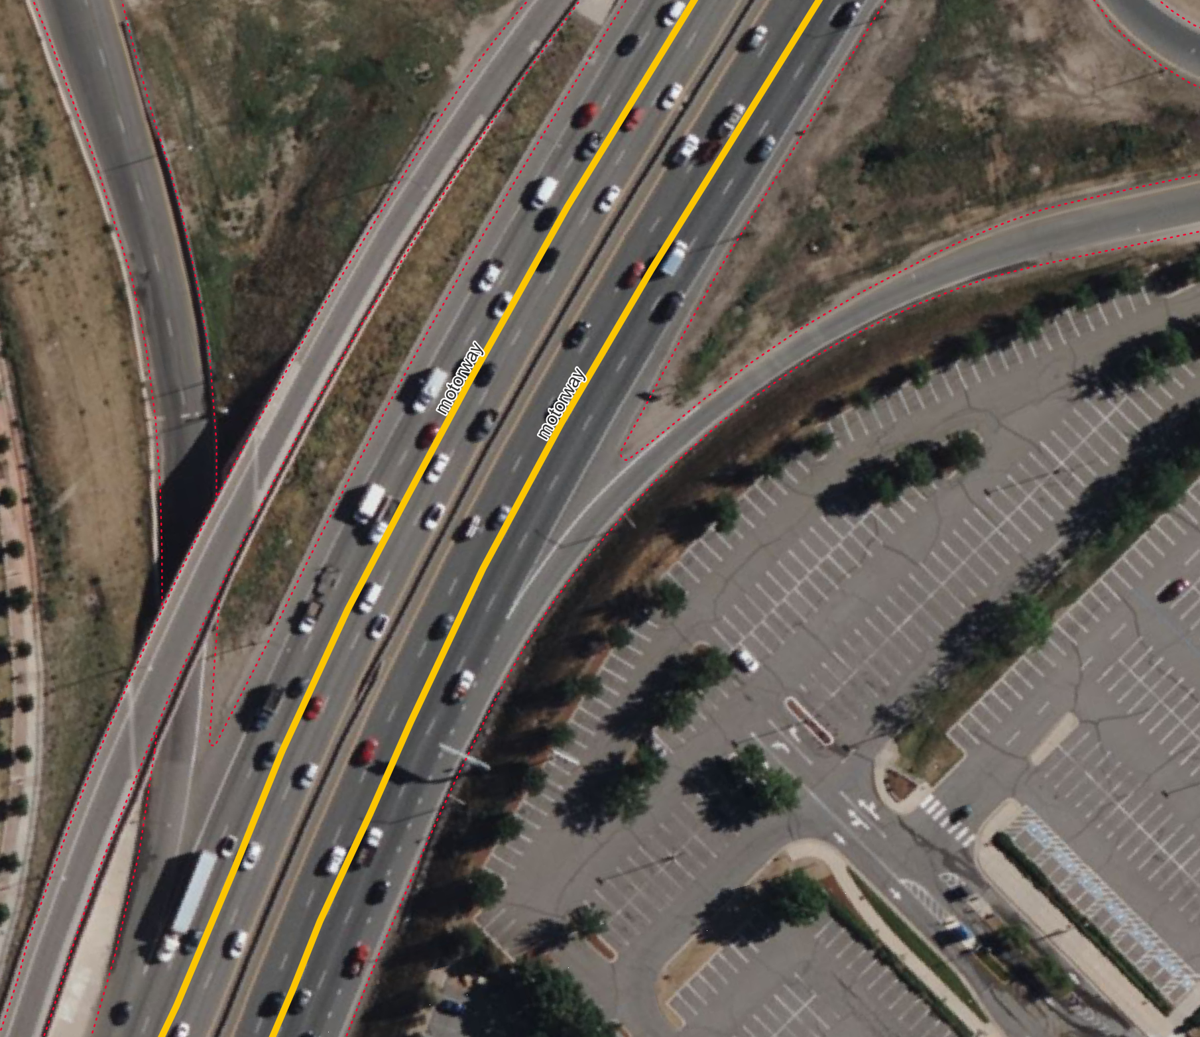The red buffer here is precise and does not include near by parking lots

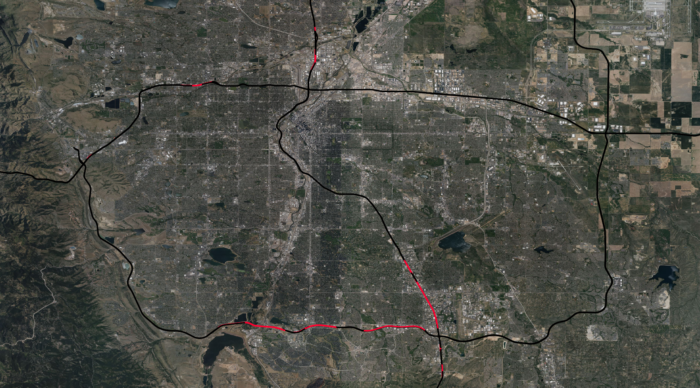Below is a zoomed out picture of all the areas that need a larger buffer

This area, on I-25 north of E470 (see blue arrow on map above for location), has the largest radius of highway I measured. I recommend increasing the buffer to 26 meters for the wide sections, indicated with “wayType = cdot_custom_motorway” attributes in the ppm edges file. This will cover all the large areas of highway, without bleeding over into parking lots or other areas off the highway.

